To talk about:

REM sleep trending and the meaning behind that:

# Blog Post 1

**Last nights sleep:**

Notes:

When looking over my sleep data from last night, I notice that the first 2 sleep cycles both contained a significant amount of slow-save sleep which are both, almost immediately, followed by a small amount of REM sleep. In general, I would hope to get a larger amount of REM in my initial sleep cycles as this is statistically significant of a good rest for the brain and allows me to convert more of my learning yesterday to long-term memory. Perhaps my dinner last night didn’t have enough carbs to get me through the night resulting in my body struggling to remain out of light sleep. In general a recovery of 68% over that length of sleep is below expectation and so I will look to eat more slow release carbs such as whole grains / sweet potatos for dinner in the future.

**Sleep performance weekly trending.**

The top plot shows the amount of slow-wave sleep (SWS) that I’ve been able to achieve over the past week. I notice that since Saturday, that amount of SWS has been in decline all the way to Wednesday. In addition, I have personally noticed since Monday that I have felt more and more run down until a longer rest on Thu Jan 30th. These 2 trends may be linked, they may not, more research required here…

I also notice a similar decline in REM over the same period with similar trends which could be linked to any mental fatigue that I have experienced over the period. But again, more research is required here… as factors such as fighting off colds etc could also be at play…

On the subject of Training Strain and Sleep Recovery:

I immediately notice that on Saturday: 1. I went out for drinks on Friday night and hence didn’t recover at all (7%); 2. I had an early night planned for Saturday and so I trained hard. Now if I then compare my actions above with the negative sleep trends covered earlier, it feels like that there is potentially a link between becoming more rundown as this week progressed and overdoing the training on Saturday.

Blog Post 2

**On the link between the heart and life (*no pun intended*)**

In this post, I ignore what Heart Rate Variability actually is as the numbers are very sensitive to the individual and simple compare the trend with the rest of my insights from the last week. Firstly, my HRV drops off a cliff when I had a poor nights recovery after beers. Secondly, it seems to then head up above the average by Tuesday which may be linked to the physical strain and mental rundown that I was experiencing in the beginning of this week. So perhaps this movement in my HRV (*and equally my resting heart rate*) is evidence of the rundown earlier this week. It’s definitely a pattern to look out for in future analysis.

Notes

Weight correlation to Waistline (Separate blog post) vs frequency of training metric

Workout avg bpm and then iqr of bpm to understand actually how volatile my hr was. Var(heart_rate) over session compared to average variance of heart_rate *normally*

Goals:

Must be < 30 sec read on one page with lots of color and clear pictures highlighting my focus point.

*Future:*

*How does HRV in a workout get affected by macros before and caffeine intake that day and recovery trends before the workout.*

*Are there any trends in strain simply over time.*

Published:

### Strain vs Sleep (Round 1)

The goal of this post is to discuss the potential links between training induced strain and it’s effect on Sleep and Sleep requirements.

There are of course many other factors that affect Sleep and Strain and even the relationship between the two. These factors might include Food, Stress, Health, e.t.c…; but for this post, sleep and strain will be the focus.

### Sources

Fore this post, I have used my own personal data from a Whoop wrist-band (€25 off [here](https://protect-eu.mimecast.com/s/7yX4C2xXxTRn6wH1UBVj?domain=join.whoop.com)). The Whoop band tracks my sleep and workouts in a great deal of depth and generates a load of interesting visualizations and statistics which I will now display and discuss.

### Last night’s sleep (29/01/2020)

The 2 types of deep sleep that I will focus on here are Slow-Wave Sleep (SWS Deep) and REM (Rapid Eye Movement) Sleep. The scientific definitions of these parts of deep sleep are outside the scope of this article. So for this post, it is enough to be aware that from my understanding, SWS is the part of sleep when the body recovers from physical strains and REM sleep is the part of sleep when people dream whilst the brain resets.

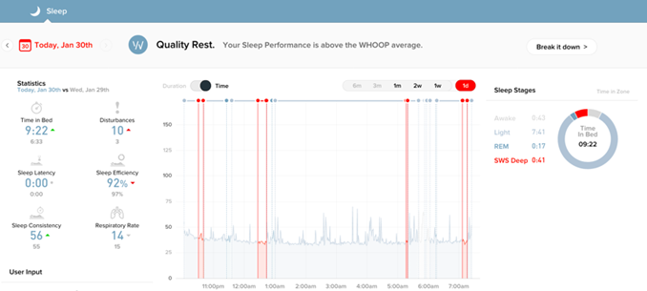Periods of Deep sleep (shown in red) last night

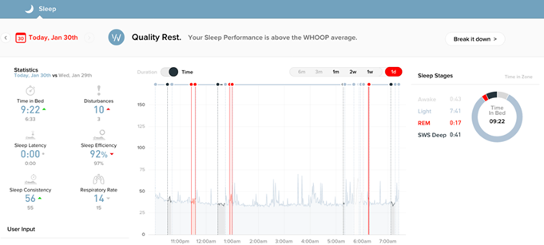Periods of REM sleep (shown in red) last night

So when looking over my sleep from last night (above), I notice that the first 2 sleep cycles (assuming SWS and REM each occur once per cycle) both contained a significant amount of SWS. Both periods of SWS are, almost immediately, followed by a small amount of REM sleep.

Is this important?

Normally, I would hope to get a larger amount of REM in my first few sleep cycles each night. This is because it is commonly discussed that 30+ minutes of REM sleep is generally reported to go hand in hand with good performance in cognitive tasks the next day. Additionally, REM enables me to remember more of the previous day whilst the brain resets during sleep.

So why might I have had less REM sleep than I would have liked?

Well one possible explanation is perhaps that my dinner last night didn’t contain enough carbs to see me through the night. This could have then resulted in my body struggling to remain in deep sleep for more significant amounts of time due to a lack of energy.

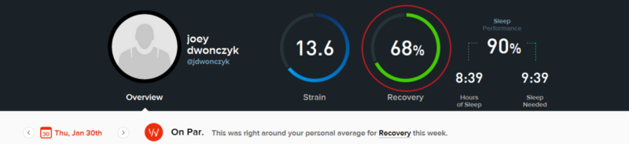Recovery Metric for 29/01/2020

This is evidenced by the above where a recovery of 68% over 8 hours 39 minutes of sleep is below my own expectation. As a result, I will investigate whether eating more slow release carbs (i.e. whole grains / sweet potatoes) for dinner allows me to sleep more deeply. Stay tuned…

### Sleep patterns this week

I feel like I really struggled through this week. Is my sleep able to evidence this and/or give me any ideas going forwards?

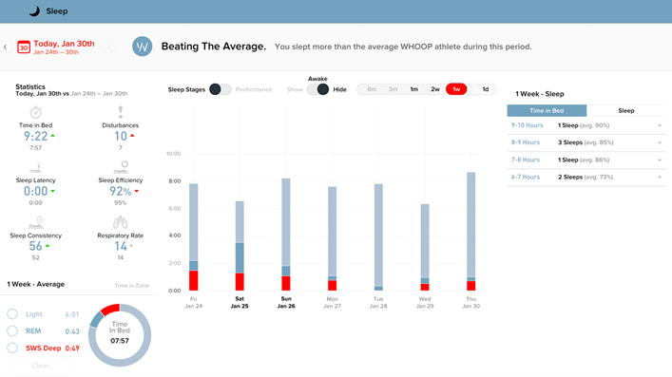SWS Deep (red) over the last week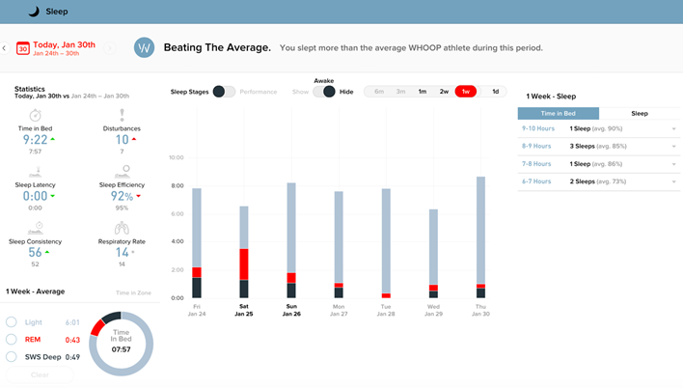REM (red) over the last week

The top plot shows the amount and pattern of slow-wave sleep (SWS) that I’ve achieved over the past week.

Firstly, from Saturday through to Wednesday, the amount of SWS declines. On that observation, I would also add here that since Monday I have felt progressively more run down up until a longer night’s sleep on Thursday. These 2 trends may be linked, they may not, more research required here…

Considering I’ve looked at SWS, I suppose I should also mention REM. I observe that there has also been a similar pattern of decline in REM over the last week. I would guess that this decline is linked to the increasing mental fatigue that I experienced over the last week. But again, more research is required here as factors such as fighting off colds etc could also be to blame…

### Strain? Does it affect sleep?

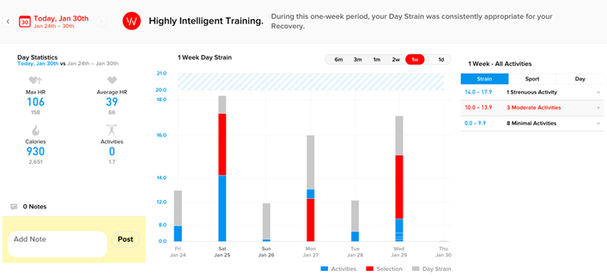Proportion of daily physical strain from moderate difficulty (red) training sessions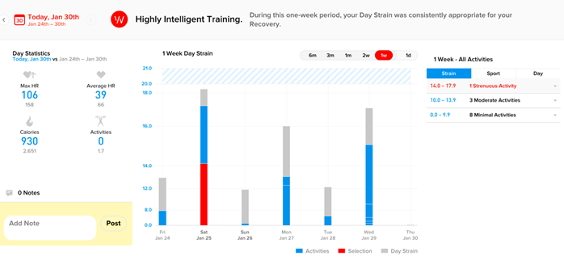Proportion of daily physical strain from very difficult (red) training sessions

To begin with, I discuss difference in this article between a “moderate training session” and a “hard training session”.

From experience, the toughest difficulty training sessions have been those where I’ve taken little to no rest either through [AMRAP](https://www.self.com/story/what-amrap-workout-is-why-trainers-love-them)s[, HIIT](https://en.wikipedia.org/wiki/High-intensity_interval_training) or intense Cardio. So as a result, all my other weights’ sessions and activities such as sport, cycling, e.t.c… fall into the category of moderate or minimal strain; the difference being the intensity of the activity.

So, on the topic of strain, what key moments can I pick out from the last week’s data?

The first thing to jump out at me is the noticeably large amount of strain on Saturday 25th. For some subjective context:

1. I went out for drinks on Friday night and hence didn’t recover at all (7%).
2. I had an early night planned for Saturday and so I trained harder than normal.

Reconsider the negative sleep trends that I observed from Saturday night through Wednesday, I speculate that this decline was triggered by the lack of sleep on Friday night (7% recovery) coupled with an exceptionally strenuous training on Saturday. The two factors combined may have over-stressed my body causing it to play catch up over the next 5 days. This, combined with the continuing moderate difficulty activities on Monday and Wednesday may have lengthened the recovery process.

On reflection, I will address the factors (alcohol) that resulted in Friday night’s poor sleep and subsequently alter my training routine in reaction to my body’s (lack of) readiness to perform.

As a reference to my definition of hard, I display the plot of my Saturday workout:

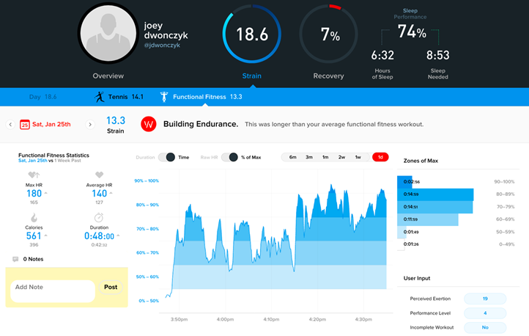Saturday 25th Workout (Heart Rate as a % of capacity)

### Who cares?

Consider the following scenarios / thoughts:

* Why do I always feel so tired on Mondays?
* Why do I find it easier to train earlier in the week than later in the week?
* Why do I sometimes struggle to sleep?
* Did I eat too much at dinner?
* Did I drink too much last night?

If you have experienced any of the above or similar ? Chances are that without analyzing your own sleep / diet / life, you could make small changes to have a big impact on the issues above.

So what are these small changes?

Due to our bodies individual requirements and circumstances, what works for me might also work for you, but equally might not. So trial and error is the best way to apply the ideas given here to see what works for you.

From my side, I will continue to uncover more I report my findings here.

So if you have read to here, I thank you and would gladly accept your thoughts / opinions. Until then…

**Error! Filename not specified.**